**Laboratory #1: Cartographic Design, Symbology, and the Modifiable Areal Unit Problem**

**Purpose:** This lab will introduce you to map layouts and guide you through how to make publishable maps and understand ways to represent data through maps. The exercises will reinforce these concepts through the creation of four map layouts that display cartographic best practices.

**Learning Outcomes:** By the end of this lab, students will be able to:

* Create map layouts that adhere to proper map visual hierarchy and use map elements appropriately.
* Label point and polygon features using different label placement strategies and labelling equations.
* Understand the different types of breaks and primary symbology for polygon features.
* Explain the modifiable areal unit problem.

**Procedure:**

1. Read the example questions in Section 1 and Section 2.
2. Repeat the example questions in ArcGIS Pro.
3. Address the Assessment questions.

**Data/Material:**

Provided with the laboratory outline:

* Links to the city of Surrey Open Data Catalog

**Supporting Documentation:**

* ArcGIS Help
* Data source: <https://data.surrey.ca/>
* Reading: Slocum, T.A., McMaster, R.B., Kessler, F.C., & Howard, H.H. (2022). Thematic Cartography and Geovisualization, Fourth Edition (4th ed.). CRC Press. <https://doi.org/10.1201/9781003150527>
* Reading: Fotheringham, A. S., & Wong, D. W. S. (1991). The Modifiable Areal Unit Problem in Multivariate Statistical Analysis. Environment and Planning A: Economy and Space, 23(7), 1025–1044. <https://doi.org/10.1068/a231025>
* Statistics Canada glossary: <https://www150.statcan.gc.ca/n1/pub/92-195-x/2021001/geo/ct-sr/ct-sr-eng.htm>

**Assignment:**

* Answer the questions (#1-6)
* The total marks available for this assignment is XX marks representing XX% of your final grade.
* All lab assignments must be completed and handed in individually.

**Format:**

* Students will hand in questions with completed answers.

**Tables and figures should be produced to the standards of the Department of Geography, Environment and Geomatics, University of Ottawa.**

**For guidelines on proper formatting and presentation of tables and figures, please see the introductory section of this lab manual.**

**Section 1: Cartographic Design**

Cartographic design is an iterative process where a cartographer conceptualizes and generates maps according to the needs of the target audience (Slocum, 2009). The primary steps in the cartographic process are:

1. Determining the purpose of the map,

2. Collecting data that can be used to portray the map’s message,

3. Designing and creating a map layout,

4. Determining whether the map layout effectively displays the map's purpose and improves the map.

The map layouts that cartographers create are impactful in nature and can clearly explain a geographical phenomenon through maps and map elements.

One of the primary forces that guide cartographic decision making is the concept of visual hierarchy. Visual hierarchy is the principle of arranging elements to emphasize more important map features by adjusting the visual contrast, size, location, and balance of the map elements. An easier way to think of it when evaluating a map is to think “what are my eyes drawn to?”. Figure 1. shows a map (left), and a version with a ranking of visual importance attributed to the map features (right).

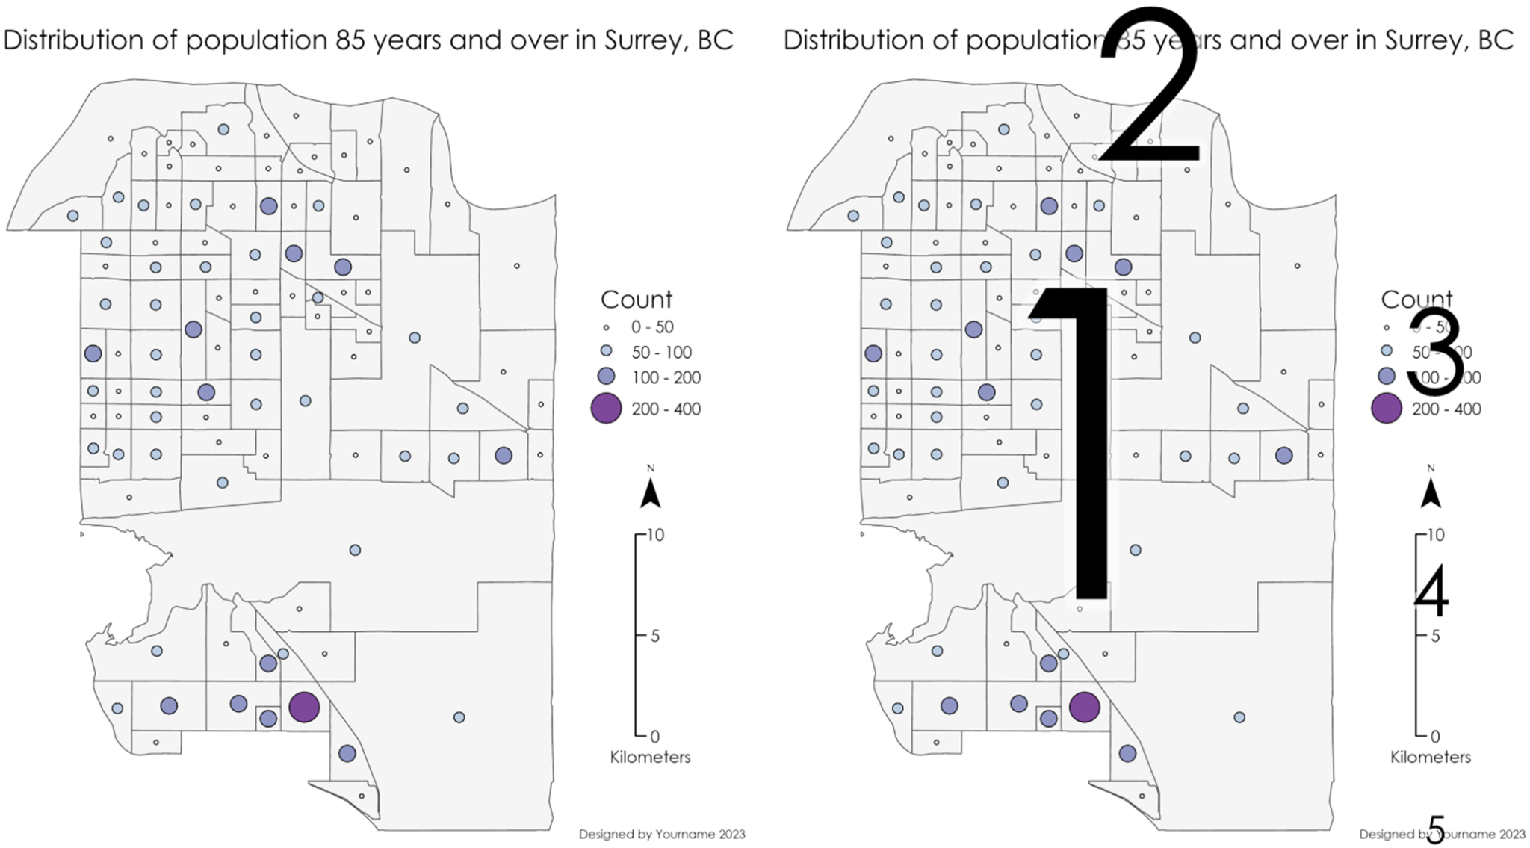

Figure 1. Two maps of Surrey, BC were created to illustrate visual hierarchy (1- highest to 5 lowest). Always remember that the geographic data is the primary object and should be the largest object taking up most of the space on a map.

The map of Surrey, BC encompasses most of the space in this layout and is the first thing that catches the viewer's eyes. The location and relatively large font size of the title make it the second most visually important thing in this layout. The size of the legend is slightly larger than the north arrow and scale bar, while the least visually important feature is the name and date located in the bottom right corner. Proper visual hierarchy leads the reader from the map to the title and then to the other map elements. The best way to achieve this is with the effective use of size and visual contrast.

Before creating maps for the exercise and assignment, consider these tips:

1. Make a sketch before you start making the map layout.
2. Consider the relative importance of each map element when deciding the formatting.
3. Fill blank space effectively with map elements.
4. Export a draft image of your map and look at it outside of ArcGIS; this can help you notice formatting that should be addressed.
5. There are many sources for help outside of this class (ArcGIS Help, Google) that can assist you when it comes to solving cartographic problems you might encounter.

In addition, the darker an object or part of an object the more visual weight it will have. So be careful and consider that when using map surrounds.

***Question 1: What is the purpose of the maps created in this lab and how do I access the data?***

The purpose of the maps in this lab will be to practice creating map layouts that adhere to cartographic best principals and display vector information about the city of Surrey, BC. The data used in this lab is accessible from the city of Surrey Open Data. <https://data.surrey.ca/>

The datasets that are required for this lab from this website include:

* Heritage sites <https://data.surrey.ca/dataset/heritage-sites>
* Important Trees <https://data.surrey.ca/dataset/important-trees>
* Bike routes <https://data.surrey.ca/dataset/bike-routes>
* Ecosystem sites <https://data.surrey.ca/dataset/ecosystem-sites>
* 2016 Surrey Census
  + Download: Census tract level and dissemination area level.

On the Surrey Open Data website, visit the web page and download each file in file geodatabase format.

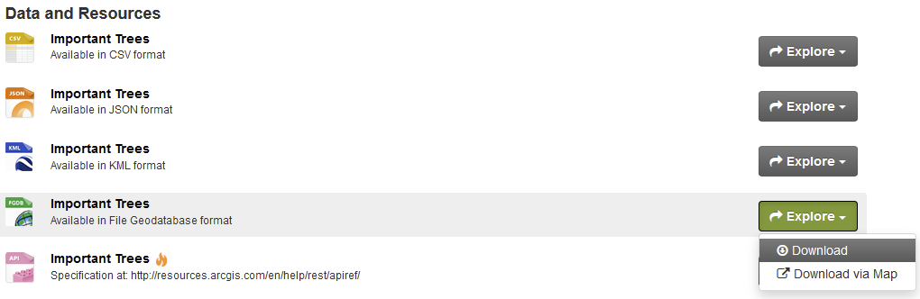

Once you have downloaded all the data (or download the single data file from the lab repository), unzip the zip file and copy all the folders that end in. gdb into a single folder named “Lab Input Data”. Make sure that the folder “Lab Input Data” is saved in the same folder as your assignment, so it is easy to find.

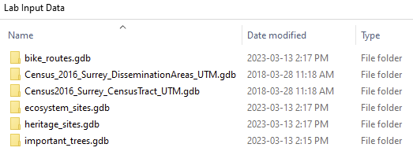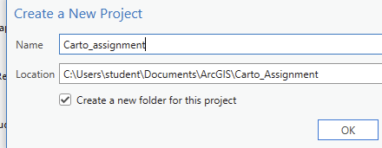

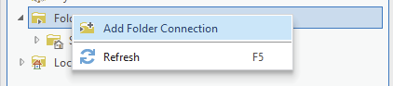

To start working on this lab, create a new ArcGIS Pro Project. The first thing you will want to do is open the catalog pane where you can access your data. On the top menu bar, click view, then catalog pane. A new menu should pop up on the left side of your screen called catalog. Click the ‘folders’ icon in your catalog and you will see an existing home folder with a geodatabase inside. By default, all outputs from ArcGIS Pro tools you run will be saved to this geodatabase and thus it is called the “Default Geodatabase”. Right click the ‘folders’ icon in the catalog menu to create a folder connection to the *Lab Input Data* folder. Once you have selected the folder containing your data (*Lab Input Data*), click ok and it will be visible in the folders section of the catalog menu. If you are encountering issues with folder connections, please refer to this website: <https://pro.arcgis.com/en/pro-app/latest/help/projects/connect-to-a-folder.htm>

**Tip**: If you see your folder in Windows Explorer, you can drag and drop the folder into the catalog pane instead of using the Add Folder Connection to create a data connection.

***Question 2: How do I create a map and symbolize a feature class?***

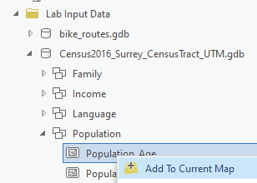For Questions 2 and 3 we are going to create a map, apply basic symbology, and then create a map layout. In the Lab Input Data folder in your catalog pane, open the geodatabase called Census2016_Surrey_CensusTract_UTM.gdb, then open the population feature dataset, and right click Population_Age and click “Add to Current map”. The map should zoom into the extent of the recently added feature class. In the contents pane to the right of the map, under drawing order, uncheck the base maps World Topographic Map and World hillshade. Then right click on population_age and click ”Symbology”. The symbology tab should pop up to the right of your map. To change the way Population_age is displayed in your map, under Primary symbology, click the dropdown menu (should be on ‘single symbol’ by default) to select the symbology you would like to use for this feature class. If you are encountering issues with symbolizing a feature class, please refer to this website: <https://pro.arcgis.com/en/pro-app/latest/help/mapping/layer-properties/symbolize-feature-layers.htm>

***Question 3: What are the common ways I can symbolize polygon feature class?***

The first question you should ask yourself when symbolizing data in ArcGIS Pro is “What kind of data am I symbolizing?”. Categorical data (names and places) should be symbolized using unique values, wherein one unique color is given to each unique category. For quantitative data (population and percentages), there are a few different ways to symbolize the data, such as Choropleth (graduated colors), graduated symbols, dot density, and proportional symbols (Figure 2).

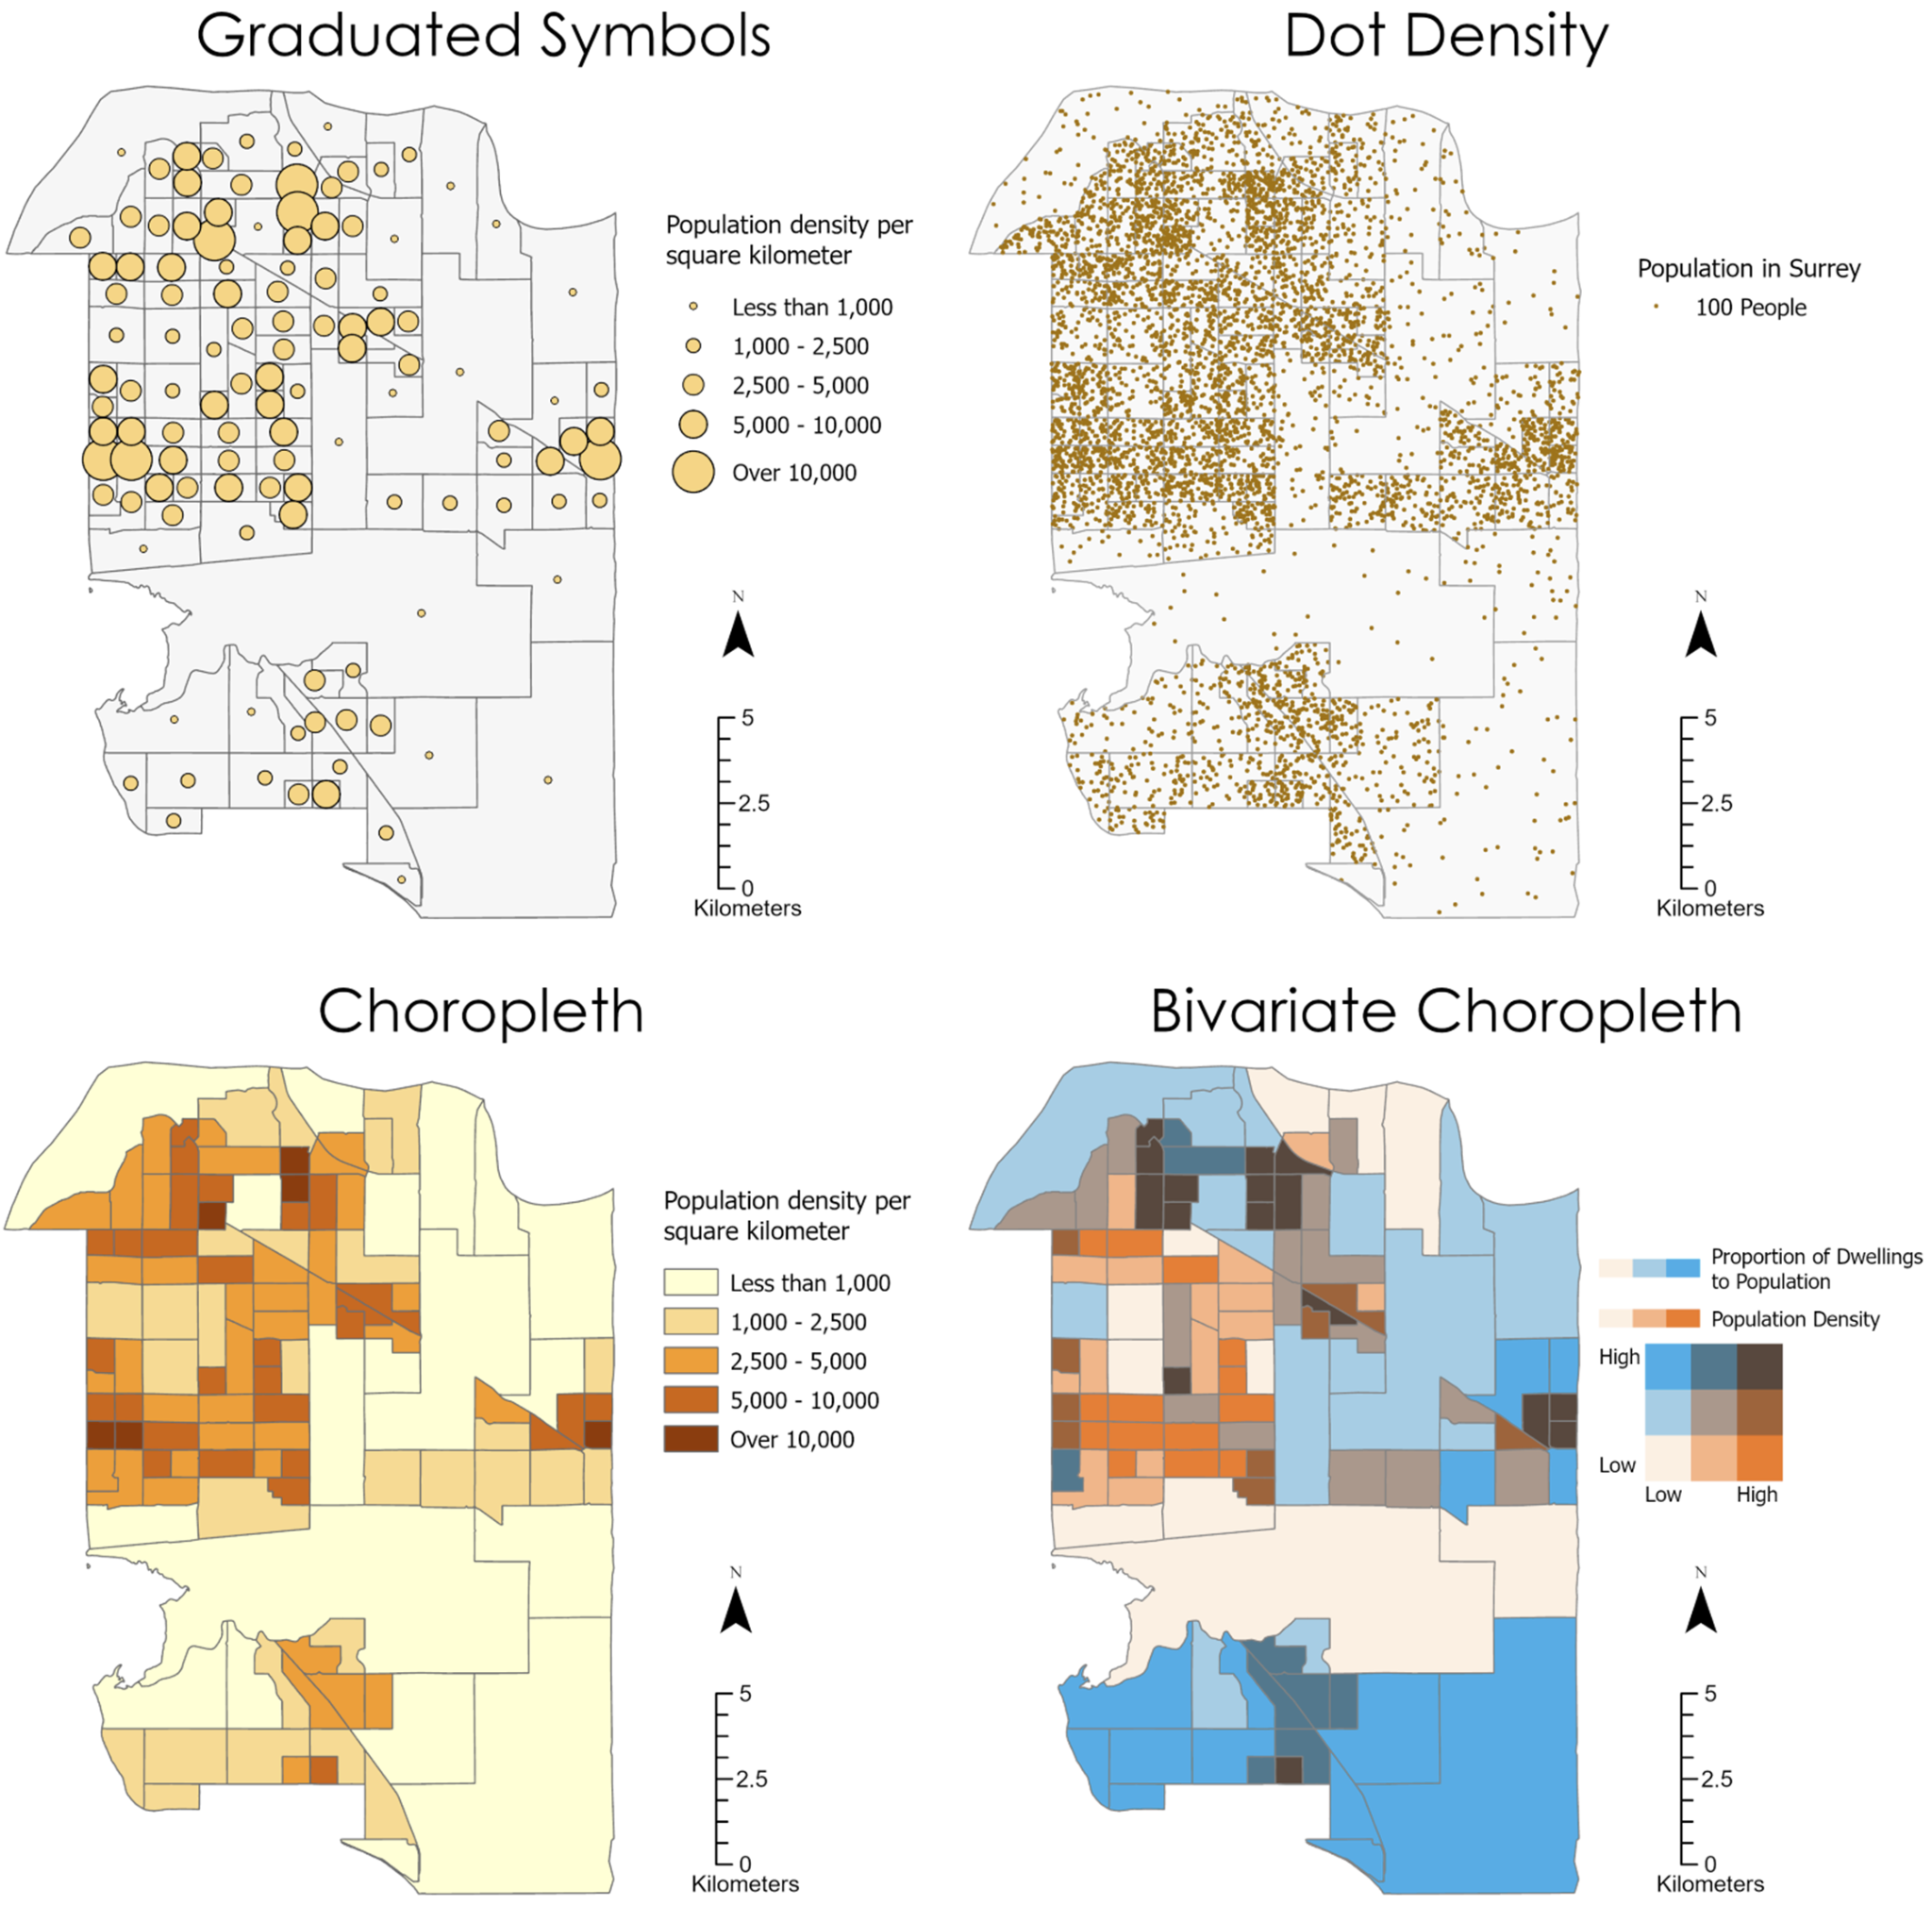

Figure 2. Comparison of different types of quantitative symbolization in Surrey, BC

The most popular method for symbolizing a polygon feature class is to use a Choropleth (graduated colors) Symbology. While Choropleth maps are easy to make and interpret, they also have several weaknesses that you should be aware of:

1. By definition, a choropleth map assumes that the data is uniformly/evenly distributed across each polygon, however, that is rarely the case. For example, in the population maps shown above, it would be unreasonable to assume the population is evenly distributed across each polygon; instead, people tend to live in residential neighborhoods, while other areas within each polygon are used mainly for transportation, shopping, recreation etc. and thus have lower population density. Examine Figure 3:

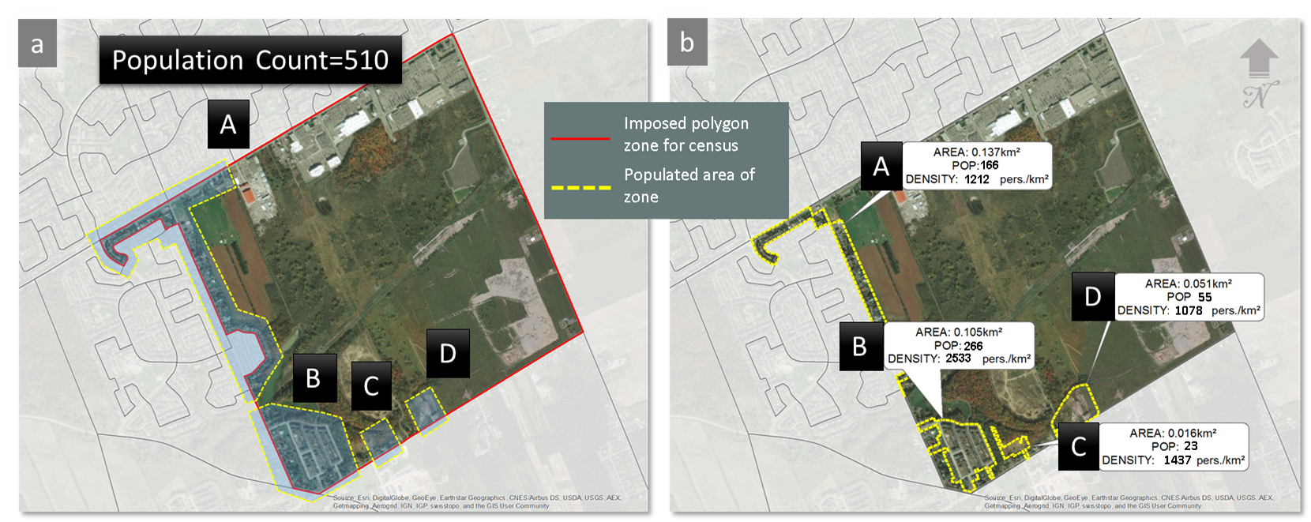

Figure 3: a) Single dissemination area zone (red outline) with a total population of 510 people. The populated part of the zone is shown in yellow and labeled A-D. Everywhere else in the zone is commercial, farmland or industrial where the population cannot reside. b) Population of 510 people disaggregated to the populated parts of the zone proportional to the area of each populated part. Notice that the assumption of homogeneity within the sub-zone populated areas is still true as the population density remains constant.

In the real world this entire polygon is allotted 510 people (Figure 3a), whereas in reality, people only inhabit the areas surrounded by the yellow dotted lines. Moreover, those little areas are not even geographically connected to each other, and each has its own unique population count and density. By now you are wondering where to stop. If we were to zoom into one of the yellow areas, we would also see more areas where people cannot live and then exclude those from population density computation to get even more accurate population densities. Should we then exclude the garage or parking spaces since people can’t live there? What about backyards? Front-yards? One could go on and on, *ad infinitum*, *ad nauseam*. In the end, no map will correspond with reality because reality is infinitely complex. Here, at most we can understand that we can better approximate reality if we understand that no quantity is naturally distributed uniformly across space unless - you can think of one?

1. To produce meaningful comparisons across zones in a choropleth, the data that is going to be mapped should be normalized, such as by mapping population density instead of the total population in each zone. This can be done by plotting the data as normalized by using the normalization drop-down menu in the symbology pane. Graduated symbols, Proportional symbols and dot density maps do not require standardized data and can be used to represent count data such as population.

For your first map, select the primary symbology to be Graduated Colors, field “Average age”, normalization “<None>”, Method “Manual Interval”, and classes “5”. Set the upper values to 35, 40, 45, 50, and 55 and update the labels. Use this map to practice cartographic elements in questions 5,6,7.

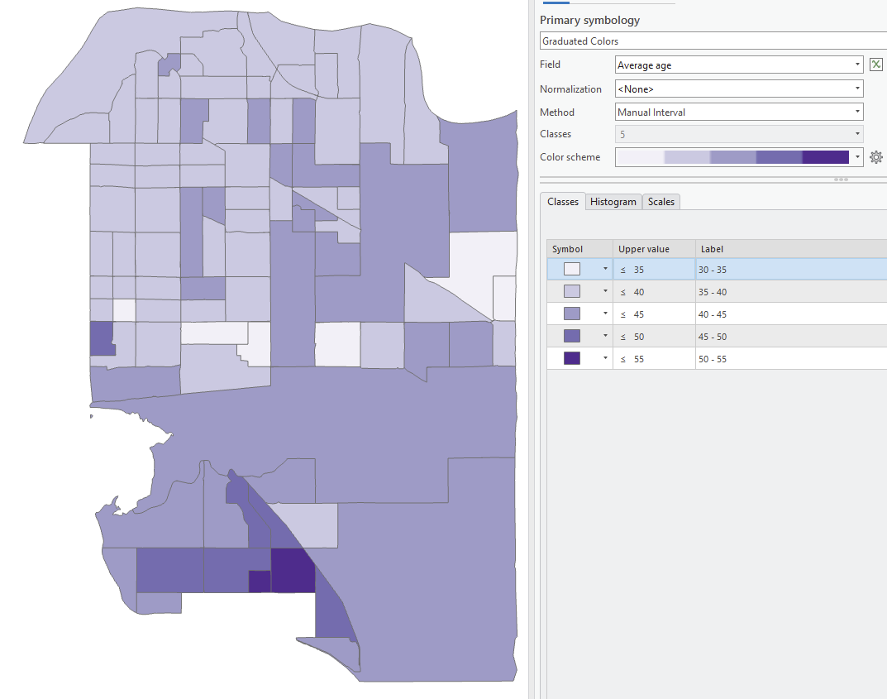

***Question 4: What are breaks and how do they affect the way my map looks?***

Class breaks (referred to as Method in the ArcGIS symbology tab) allow you to visualize quantitative ranges of data. Class breaks methods include Natural Breaks (Jenks), Equal Interval, Manual Breaks, Standard deviation, Quantile, and Geometrical interval. The map layout below (Figure 4) shows four of the most common class break methods. More information on class breaks methods can be found here: <https://pro.arcgis.com/en/pro-app/latest/help/mapping/layer-properties/data-classification-methods.htm>

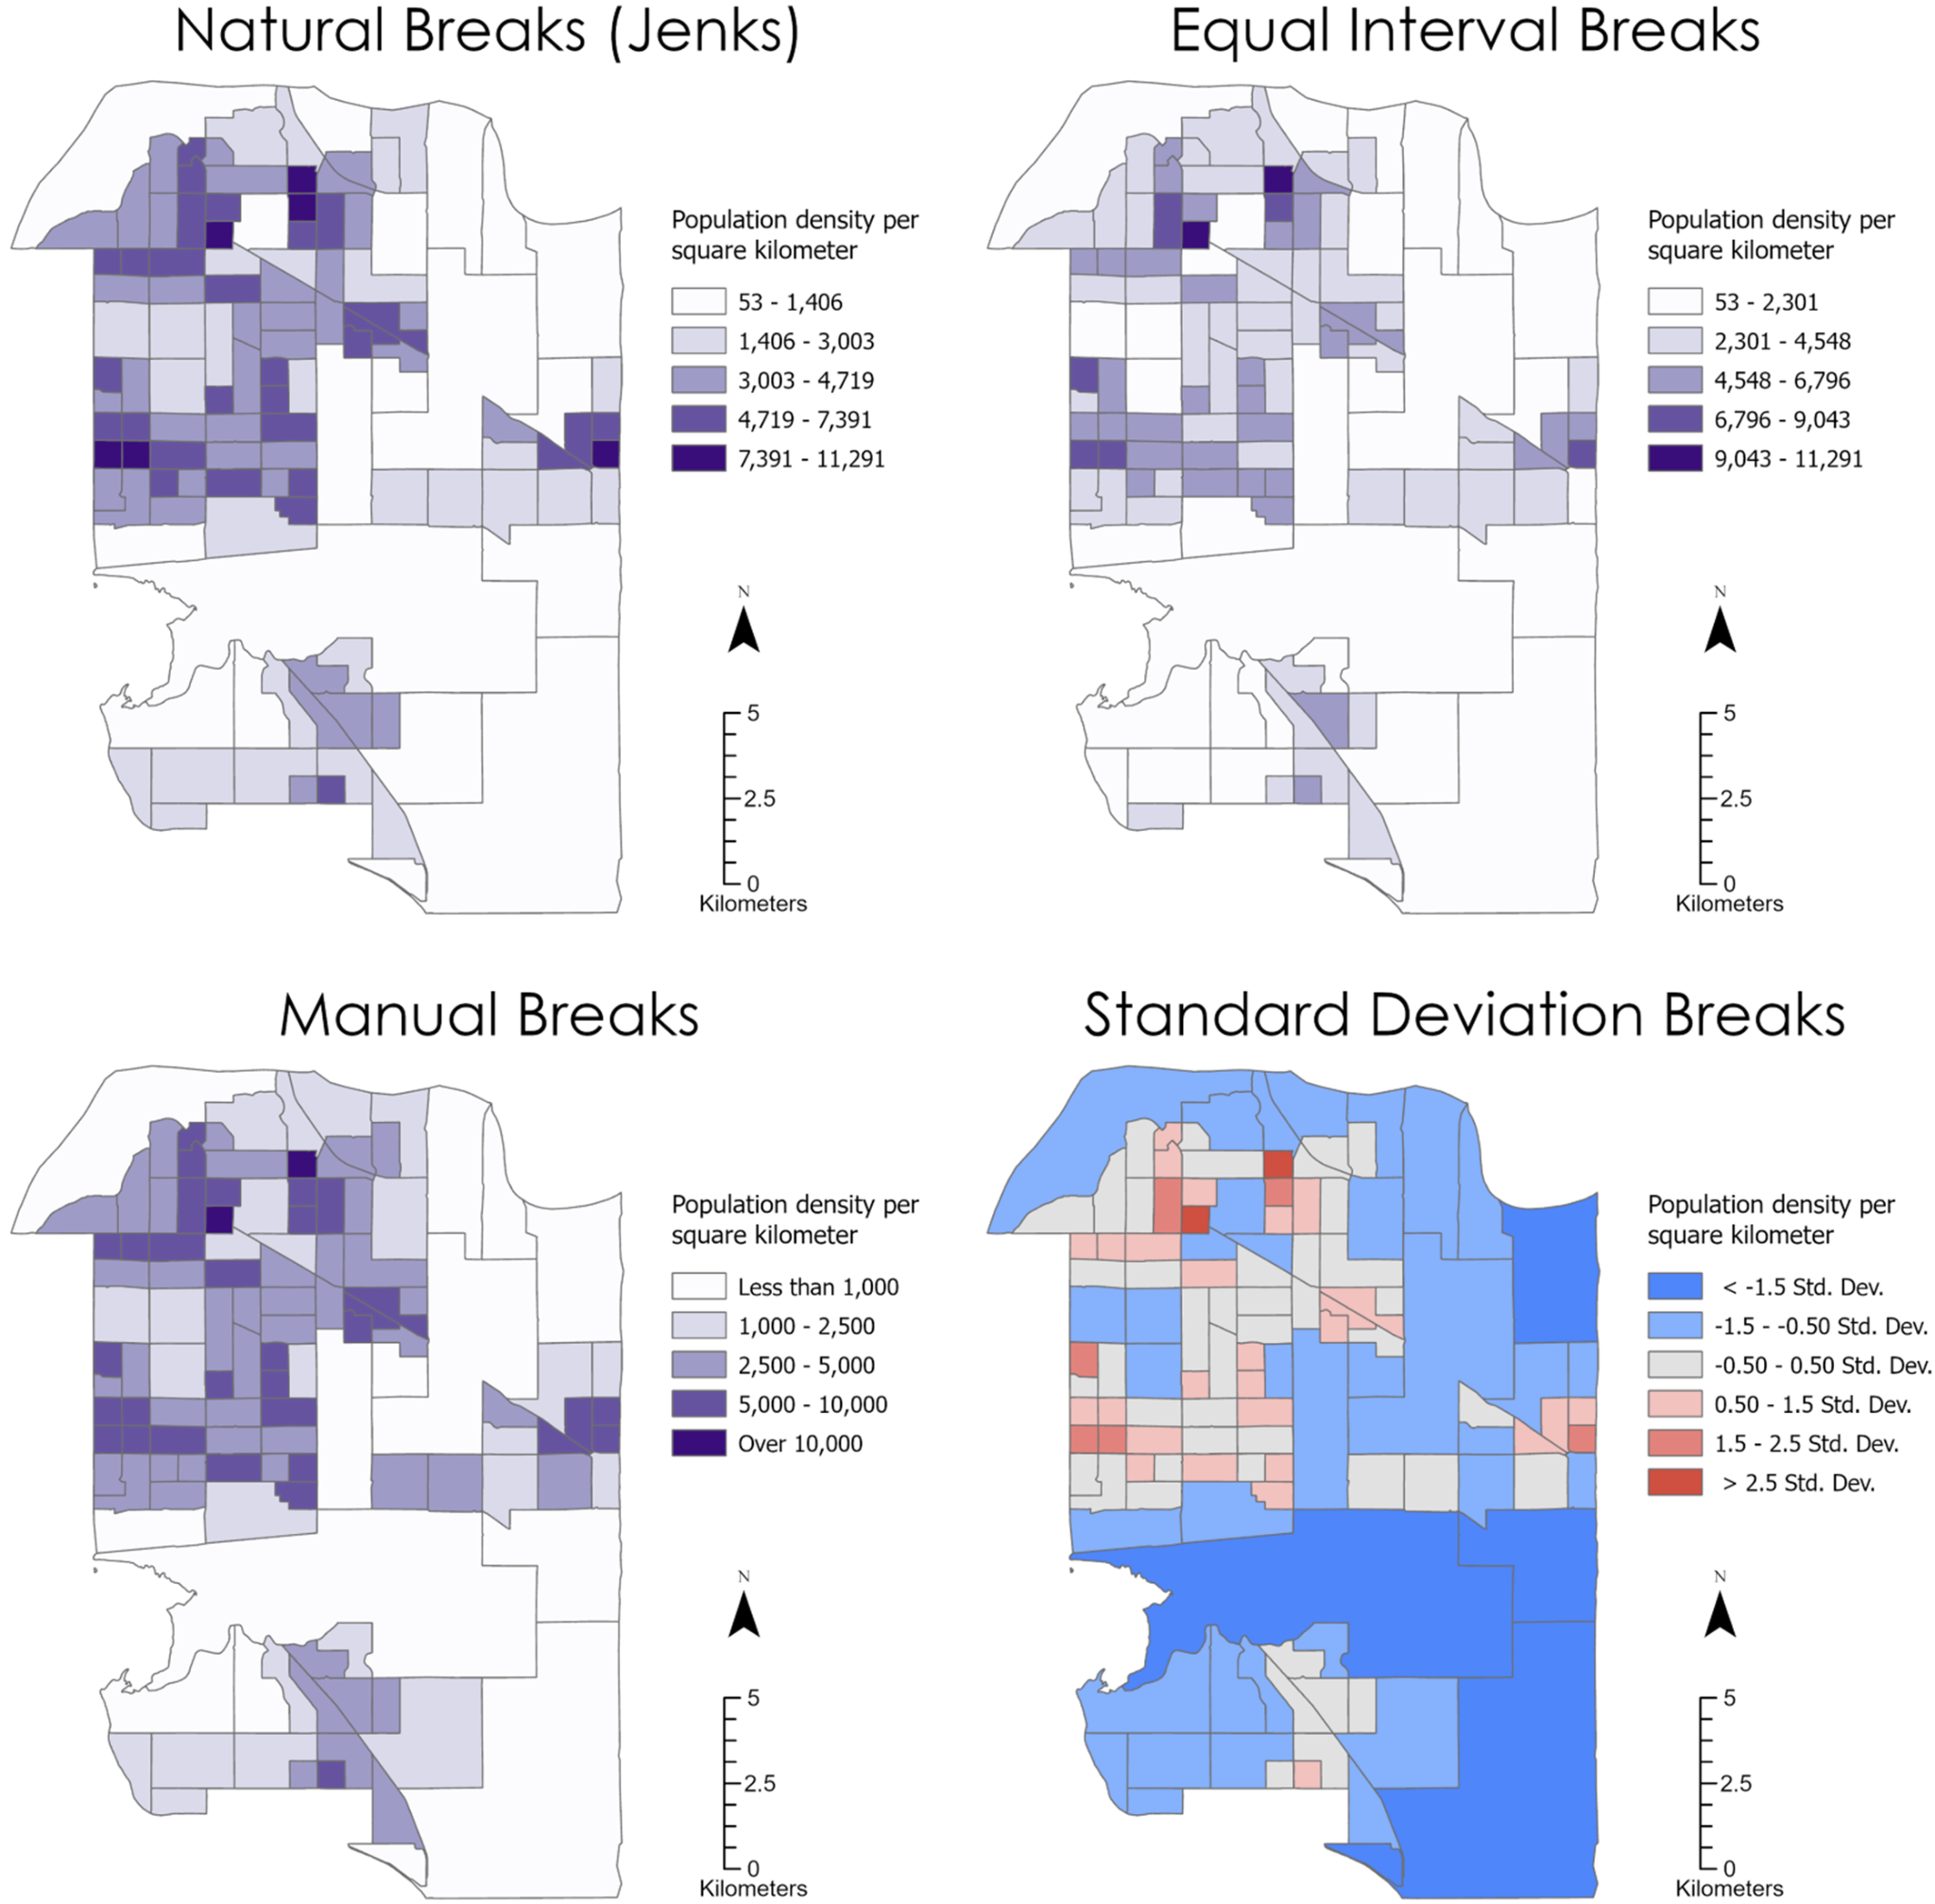

Figure 4. The most common methods used for class breaks visualized using Surrey BC population data.

Determining the appropriate class break method is a cartographic decision that can impact the message that the map is giving. Class breaks also partially determine the type of color scale that can be used and that in turn is ultimately a function of the kind of data being mapped. A guiding rule is that manual breaks should be used most of the time if you are describing your data with numeric values, such as population density per square kilometer. It is much easier for readers to understand and visualize numbers such as 1,000 people per square kilometer, rather than 1,461. If you are describing your data in categories such as low, medium, and high, Natural breaks or equal interval breaks might be more appropriate. You can also adjust what is displayed on the map next to each break by altering the label column in the symbology pane and change the color scheme by either changing the color of each break, or by selecting a color scheme from the dropdown menu.

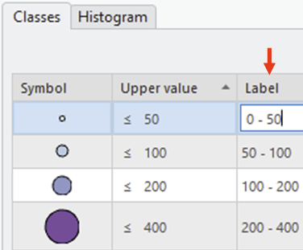

***Question 5: How do I create a map layout and set the map scale?***

The first step to creating a map layout is to visualize where you want to put the map and map elements. It is recommended to make a quick sketch on a piece of paper or spend a bit of time thinking about where you want to place the map and map elements (Title, legend, north arrow, scale bar). The next step is to decide on a page size and orientation that fits with your map sketch. If your map takes up an entire page, it is recommended that you select a letter page size. However, if you are making a map for digital purposes, or are generating a map that will be part of a report, it is recommended that you set up a custom page size. Squares (20cm x 20cm) are a common page size to allow for easy division of the page to make cartographic layouts. The most effective page layouts are created when cartographers look at the map, they are trying to make along with the map elements, and then choose a suitable page size. For example, since Surrey, BC has more height than width, your choice in page size should reflect this. Note that you can always change your page size after you have started working on your cartographic layout.

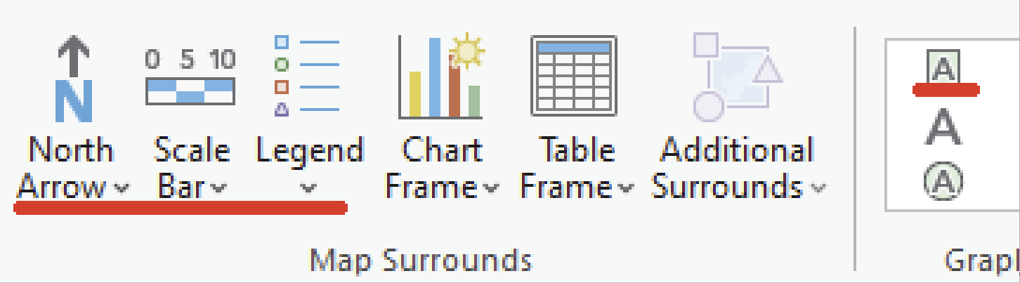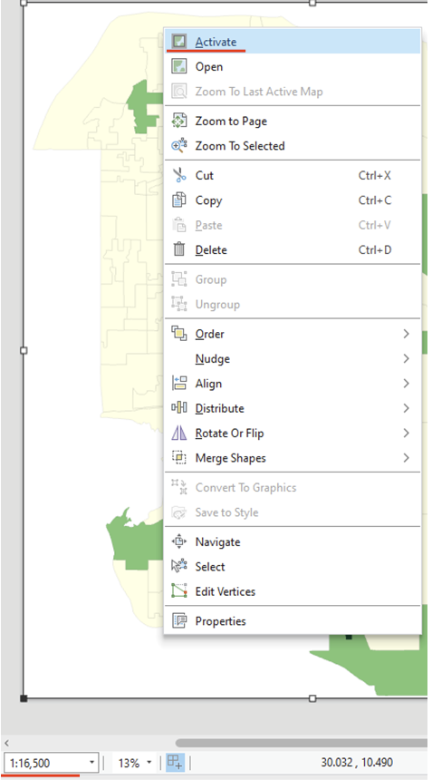To create a layout on the insert tab in the Project group you just click on the New Layout button. After you have started a layout in ArcGIS Pro with a blank page, click insert, then map frame, and select the Map you would like to insert into your layout. Consider the map frame as the outline for where your map will fit on the page. Draw a map frame and then right click on it and click activate. Once you have activated the map frame, you are able to move the map around the map frame and zoom in. The map scale (with the red line underneath it in the bottom left of the image) can be manually set to zoom in or out by larger or smaller ratios respectively. Once you have placed your map appropriately, click on the “layout” button in the top menu bar and click “close activation”. This will prevent further modification to your map within the map frame. Additional tips and resources for setting up a map frame and how to remove the map frame border can be found here: <https://pro.arcgis.com/en/pro-app/latest/help/layouts/add-and-modify-map-frames.htm>

After placing your map, go to the upper menu ribbon, find the Map Surrounds group, and select an appropriate north arrow, scale bar, and legend. Also, in the Graphics and text sub-menu in the upper menu ribbon, select rectangle text and draw a box for the maps title. Rectangle text is better than drawing a straight text box, because it gives you more options if you want to add a background to your textbox. Keep in mind that you don’t put a title on a map that is not a stand-alone map, that is to say, if you have a question that asks for a map only then the map should have a title, if you have a question that asks for a map and interpretation of some maps then you omit the title and instead use a numbered figure caption. This is explained in the forward with examples.

Additional resources for map layouts can be found on this page and the following sections in ArcGIS help:: <https://pro.arcgis.com/en/pro-app/latest/help/layouts/layouts-in-arcgis-pro.htm>

***Question 6: How do I design good-looking map elements?***

This section will briefly go over some tips to improve your map elements and make them look more professional.

1. **Legend or key**

It is recommended to use the legend properties to alter the features in a legend (sometimes called a map key). Similar to the drawing order found on a map, you can turn on and off layers in the legend to decide on which symbols you want to be present. Consult Esri help for more tips on how to format legends using legend properties: <https://pro.arcgis.com/en/pro-app/latest/help/layouts/work-with-a-legend.htm>

One thing to note is that it is sometimes much easier to work with designing a legend when it is a graphic in ArcGIS Pro. This should only be done if you are set on the color scheme and do not plan on making any further changes to the contents of the legend (like adding another feature).

If you are planning on making multiple maps and plan on using the layout as a template, it is recommended that you update the legend in legend properties. Otherwise, when the legend is in graphic form, it is easier to fine tune the legend and make it look more professional. To convert a legend to a graphic by right-clicking on it, then click “Convert To Graphics”. Then if you right click and ‘ungroup’ the graphic, you can easily move the individual part of the legend like symbols and text (you may need to ungroup the graphic twice depending on the complexity of your legend).

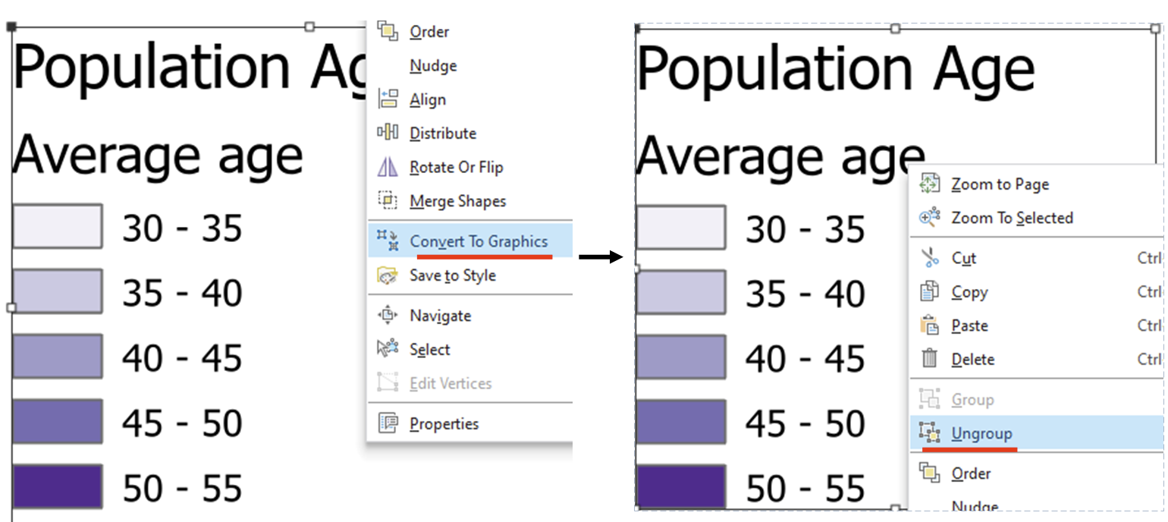

You can use guides to line up map elements and legend symbols and text to improve consistency in the spacing and layout. Once you have altered the legend elements, select all the text and symbols, and right click ‘group’ them so you can move the legend around your map layout as a single feature again.

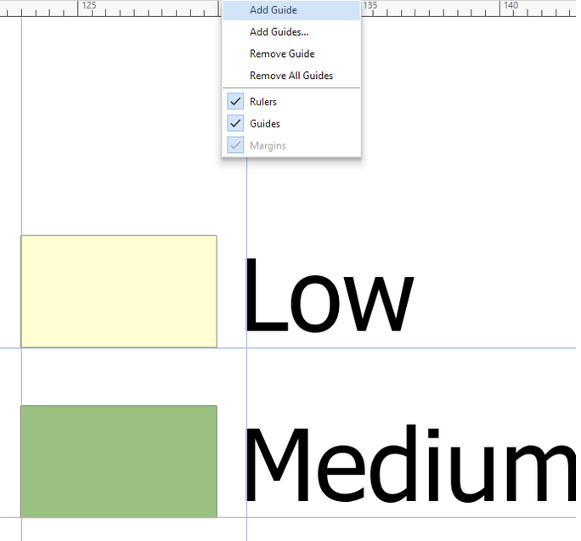

The image above displays how guidelines can be used to format a legend, with consistent spacing between the text and symbol.

1. **Scale Bar**

The default scale bar is usually not the most interpretable, so expect to have to alter the scale bar on most of your map layouts. Once you have placed a scale bar, click it once and the design menu should pop up in the upper menu ribbon. Open the design menu to find helpful tools for adjusting your scale bar. The fitting strategy is crucial because it determines how the scale bar is adjusted - typically “Adjust width” is the easiest to format. Then, alter the division value, divisions, and subdivisions to alter the display of the legend. Make sure you are using appropriate distance units, metric is the rule unless otherwise stated. If you want to fine tune your scale bar, you can convert it into a graphic (similar to a legend). You can do this to remove unnecessary division values, or easily flip the scale bar vertically for portrait layouts. Note: once you have a scale bar as a graphic, altering the size of the graphic distorts the scale; you should never do that.

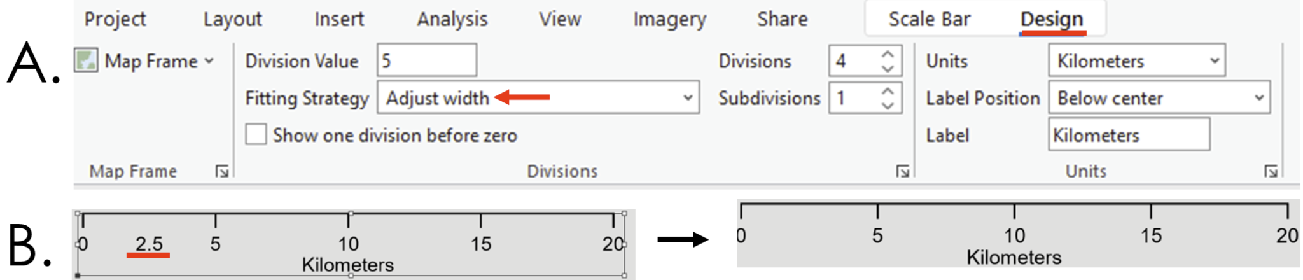

1. **North Arrow**

North arrows are relatively simple to implement in ArcGIS Pro. Typically you want a simple north arrow, and the size of it should be sufficient to understand what it is, but not too much larger. The North Arrow is a map element with relatively lesser importance than others and should be present on the map layout but not take up too much space. One should need to look for it rather than see it right away.

***Question 7: How do I export a map?***

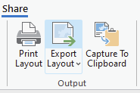Once you have completed working on your map layout, click share in the top menu bar, then “Export Layout”. You will be prompted to set a file type, and PNG is recommended due to its smaller file size. Set the DPI to at least 300 and define the file name and file path. You can use the clip to graphics extent to remove blank space in your exported map.

***Question 8: How do I label map features?***

Labeling map features is important to provide context and information about the features that you are mapping. This section will go over how to label maps, label placement, and label formulas for point and polygon features.

To start, place the **heritage_sites**, **bike_routes**, and **ecosystem_sites** on your map in ArcGIS Pro. They will be located in their respective geodatabases in your **Lab Input Data** folder. In the upper menu ribbon, select you map, click on Select By Attributes, use input rows ‘heritage_sites’ and the clause Where SITE_NAME is equal to Port Kells Fire Hall No. 7 (see image below).

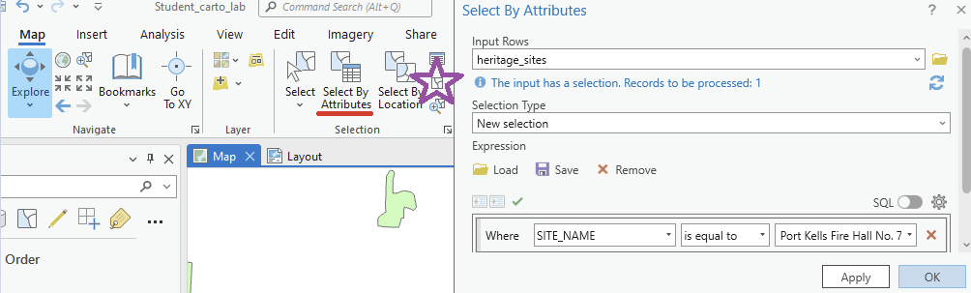

Click “Ok” and a light blue mark will pop up in the northwest corner of Surrey, BC. Zoom into that region since we will be mapping the Port Kells region of Surrey in this section of the lab. Then, in the upper menu bar, click the deselect button (purple star in the image above) to deselect the fire hall.

To enable the label for **heritage_sites**, click on **heritage_sites** once in the Content pane, and then in the upper menu bar click Labeling and then click Label. Ensure that the field is set to SITE_NAME to display the names of the heritage sites.

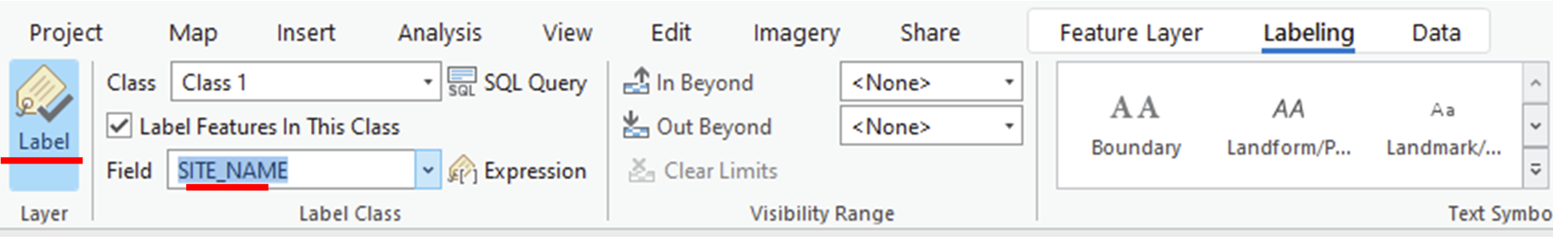

More information on labeling can be found here: <https://pro.arcgis.com/en/pro-app/latest/help/mapping/text/labeling-basics.htm>

***Question 9: How do I alter the placement of labels?***

For this question, we will focus on altering the label placement of a point feature. There are two primary ways to adjust the location of point feature labels, adjusting feature weights and changing the placement preference.

The feature weight property can indicate the relative importance of certain map features from others. You can alter the feature weights by right-clicking on a map feature in your content pane and clicking “Labeling properties”. In the newly opened label class pane, click position, feature weight, and you can alter the feature’s importance. In the example below, the feature weight of the bike lanes was increased to prevent heritage names from overlapping with the bike lanes. More information on feature weights can be found here: <https://pro.arcgis.com/en/pro-app/latest/help/mapping/text/prevent-labels-from-overlapping-certain-features.htm>

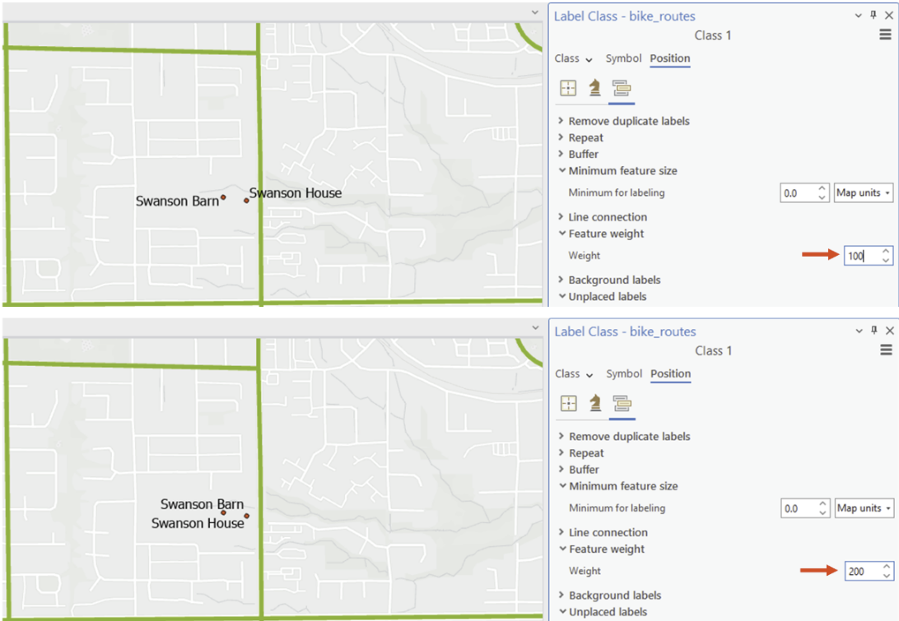

Another method for label placement, which can be used independently or with feature weights, is defining the positioning preference in the label properties. In Figure 5a, the two labels are a bit confusing - it is not easy to see which point Swanson Barn and which point is Swanson House. By changing the label positions (swapping the 2 and 4 positions), the labels can be placed more clearly in Figure 5b.

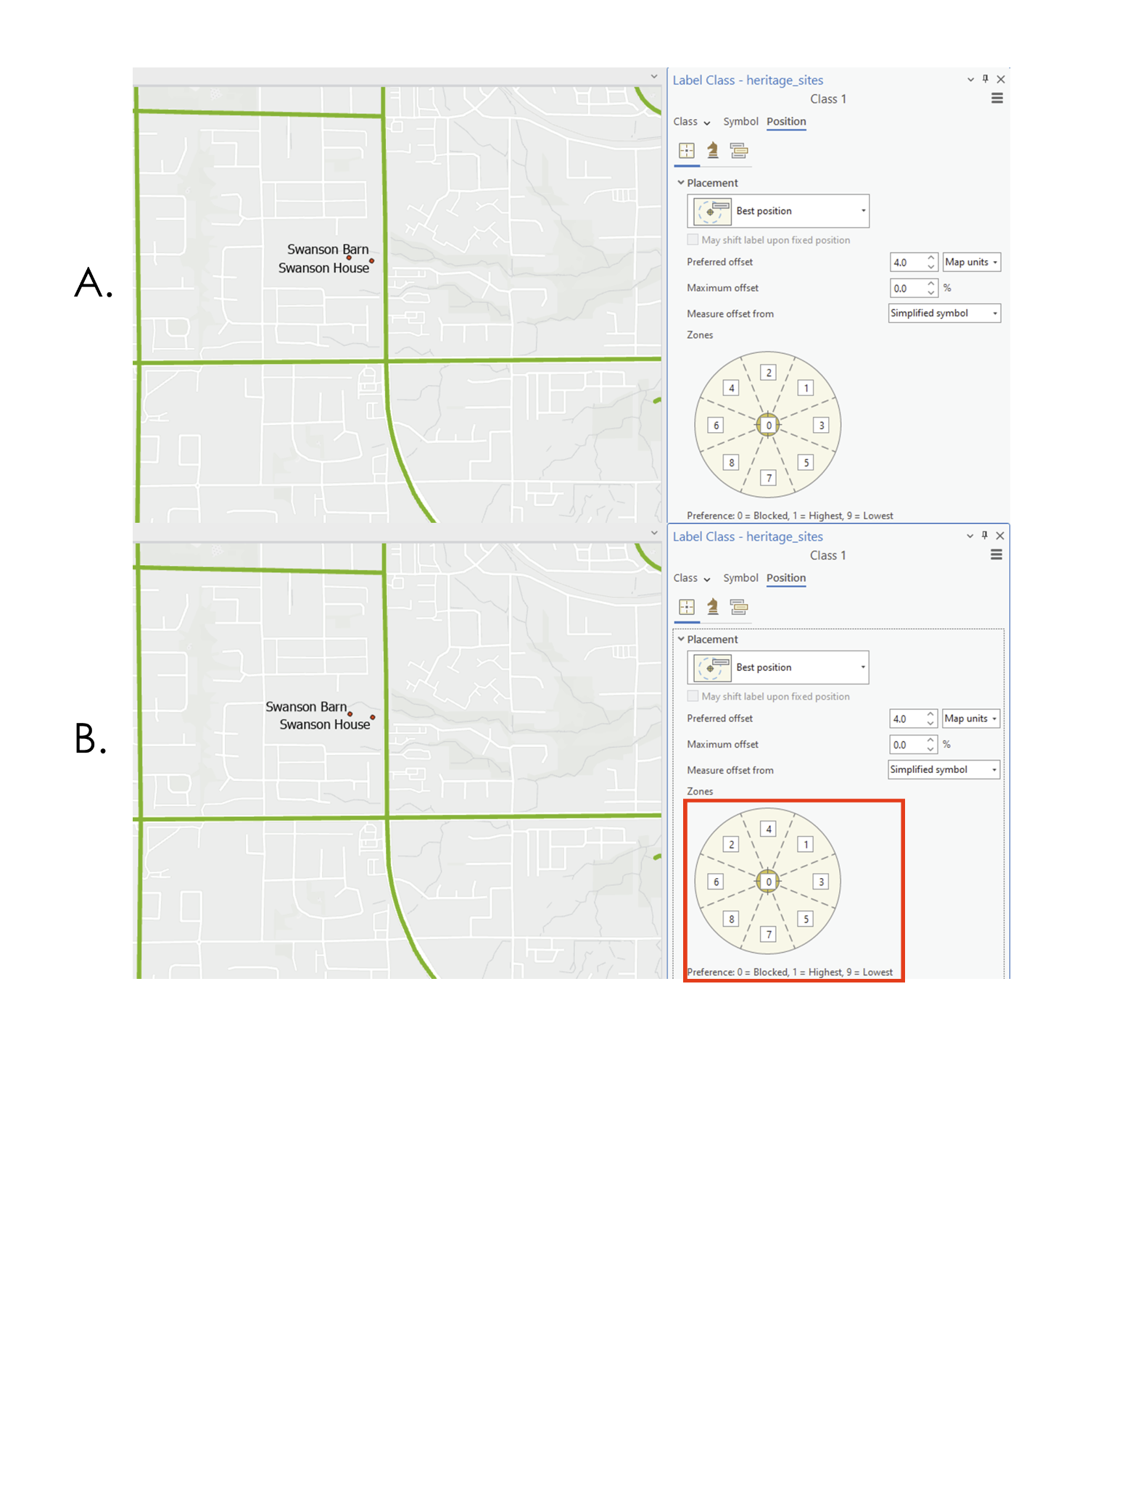

Figure 5: Labelling options for maps in ArcGIS Pro

If the features are very complex and you are finishing a map layout, sometimes it can be best to alter the label positions manually. In these instances, the convert labels to graphics tool can be used. <https://pro.arcgis.com/en/pro-app/latest/tool-reference/cartography/convert-labels-to-graphics.htm>

**Section 2: Modifiable Areal Unit Problem**

***Question 10: What is the Modifiable Areal Unit Problem (MAUP)?***

The modifiable areal unit problem (MAUP) describes an effect whereby data reported in spatial polygons affect the mapping interpretation of patterns as well as the analytical results of data collected within those same polygons (Fotheringham et al., 1991). An extreme example of MAUP is [gerrymandering](https://docs.google.com/document/u/0/d/10mq-32_lJPtcYRESMAnpF2DjllVEXZ_CZ75RWZk8Cuk/edit) in the United States, where modifying the specific boundaries of an electorate will alter the results of an election. Most instances of MAUP are more subtle in nature, but nevertheless it is important to consider the way that your spatial polygon data is defined (e.g., how the polygons are made, or the boundaries are determined, called zonation and scale (size) and how changes in polygon geometry can affect the results of any spatial analyses including how data appear on a map. The MAUP is present whenever you analyze data that is connected to polygon features or image (raster) features. When you are mapping something in a region and are using polygons, most commonly those polygons divide the entire region into a set of non-overlapping polygons and that is called a tessellation because they fill the entire space.

As an example, consider the location of some population in space, say people picnicking in a field that is flat with no trees and just short grass (a homogenous field) (Figure 6).

Figure 6. People in Krüöppen field on national festival day; Left: photos of picnickers; Right: Square quadrant overlain on portion of picnic field. Image created using DALL-E and Adobe Photoshop.

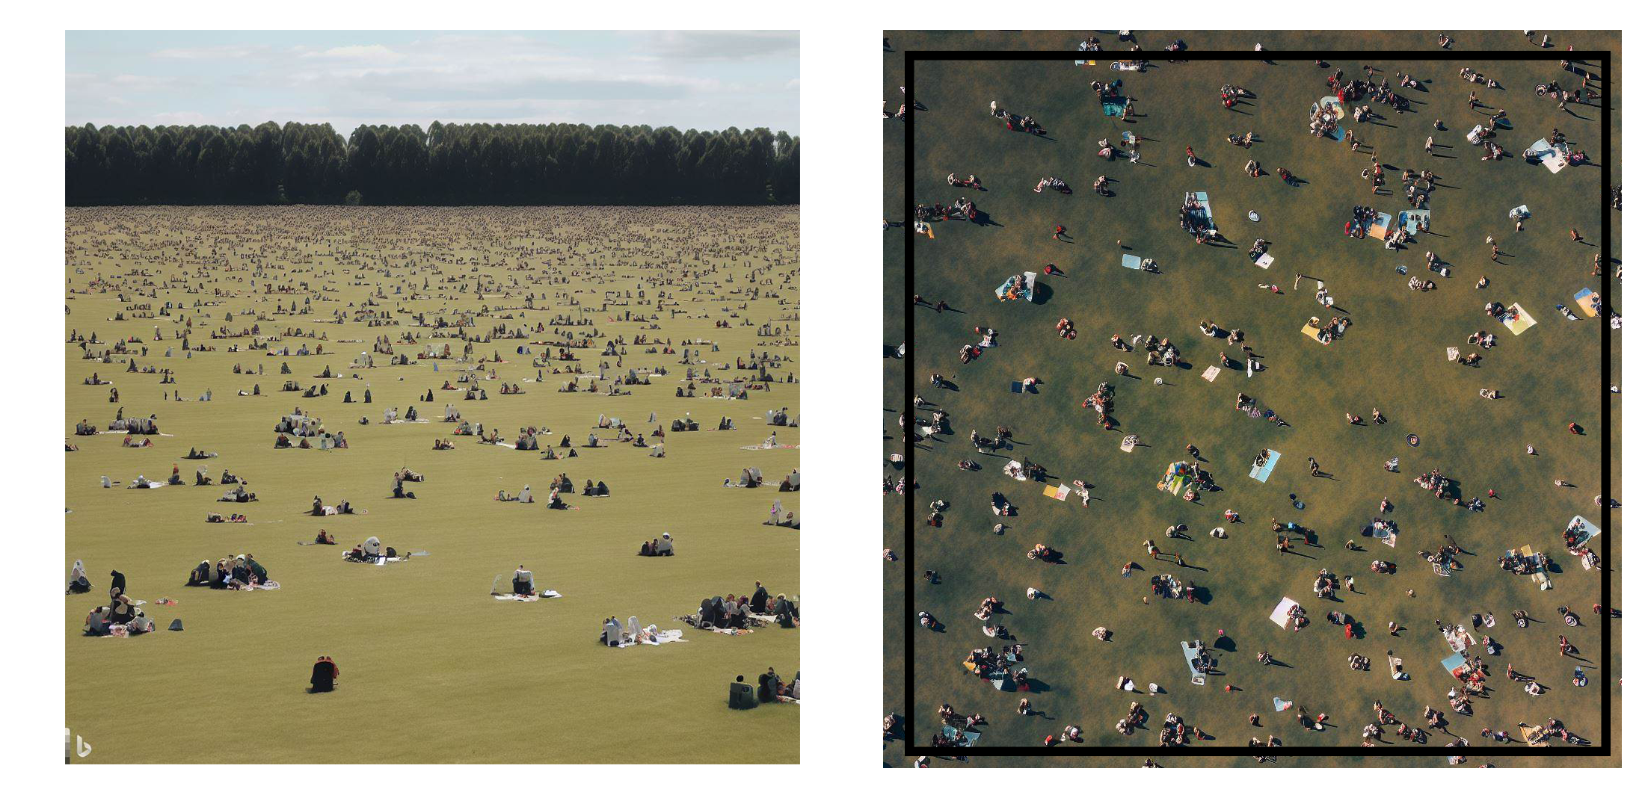

Then we overlay a quadrant (a large square) on a random portion of that picnic field (Figure 6). Next, we divide that quadrant into a set of 10 polygons and count the number of people within each of the 10 polygons. When we count points in polygons that is called a point-in-polygon operation. Next, we make another set of 10 polygons that have different sizes (scales) and shapes (zonations) and repeat the same point-in-polygon operation. Then for each of our polygons we divide the counts by the area of the polygons to create the number of people per polygon. That is a density value, and we can show that on a choropleth map with the continuously varying color for the map scale/key. The result is illustrated in Figure 7.

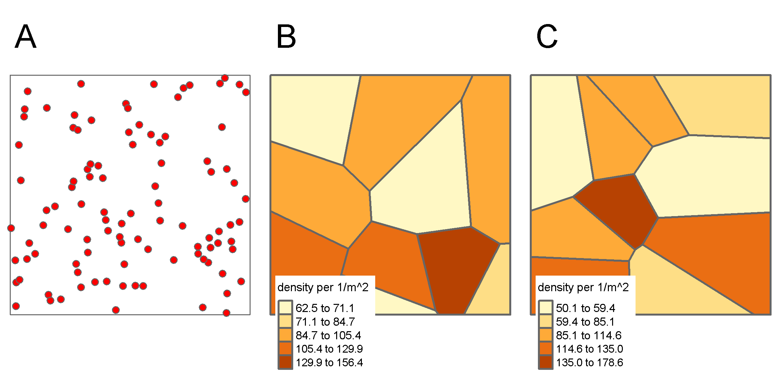

Figure 7: A) the distribution of population in some region where each red dot represents 1 thing (person, object etc.); B) a tesselation of the region with polygons showing the density of population in each region based on the points shown in A; C) A different tesselation of the region with the same number of polygons as in B but different densities and using the same population in A.

From Figure 7, it is clear that two different polygon tessellations of the same space provide very different maps of the density of picnickers. Examine just the values of minimum and maximum density in Figure 7b & c, the ranges are different. If you were asked to describe where the highest density of picnickers is you would conclude from Figure 7b that they are in the bottom right of the field, whereas if you used Figure 7c, you would conclude they are near the center of the region. Despite the picnickers remaining stationary as shown in Figure 7a, the conclusions drawn are significantly different due to the utilization of two distinct polygonal tessellations or zonations. These zonations, while containing the same quantity of polygons (10 in each map), differ in boundaries and scale. This difference in spatial partitioning has resulted in diverse values and interpretations. Such variances are a direct consequence of the Modifiable Areal Unit Problem (MAUP).

The Modifiable Areal Unit Problem (MAUP) essentially ensures that distinct results emerge when the same analysis (like the point-in-polygon analysis depicted in Figure 7) is conducted on an identical dataset, given that the dataset is represented within polygons differing solely in boundary location (zonation) and area (scale). Put simply, the geographical scale of data analysis and the defined boundaries for the area can significantly influence the outcome of the analysis. The two components of the MAUP are thusly the:

Zoning Problem: This involves the emergence of different results when using the same underlying data when the arbitrary nature of the boundaries used to summarize that data are so called imposed spatial units (Bonham-Carter 1993) - even if the physical area/scale of those units is kept constant, the boundaries themselves could be changed and thereby the results of any analysis using the data summarized in those polygons can change as well. Thus, how you define the polygons you use for analysis directly influences the outcome of any measures.

Scale Problem: This refers to the fact that results from statistical analyses will be different based on the spatial scale of analysis. For instance, analyzing data at the level of a neighborhood (a large unit) might yield different results than analyzing it at the level of individual census tracts (smaller units). In a similar vein, a geological map might depict a substantial geological formation, such as a sedimentary basin or igneous intrusion. This larger formation may encompass smaller, nested units of diverse rock types. If you undertake an analysis, like evaluating hydrogeological parameters such as pressure per geological unit, you will find that the results vary depending on the size of the geological units you examine. In essence, the scale of the geological units used in your analysis can significantly influence the outcome. As the scale changes (from small-scale, like a country, to large-scale, like a neighborhood or a geological formation to a rock type), the data analysis will reveal different patterns or relationships.

In reality, these two aspects of the MAUP are not separable for a given polygon-based dataset. These problems highlight the challenges of spatial analysis and the importance of understanding the influence of spatial scale and zonal boundaries in analyzing geographical data. It's important to consider the MAUP in designing studies, interpreting results, and making policy decisions based on spatial data because what might be true for one zonation and scale might not be so at another. To see how this is a law of geography, see Box 1.

To understand what types of analysis might be affected by the MAUP, let's consider the correlation between two geographic variables that are distributed randomly in space. All you need to know is that correlation is a statistical measure that indicates the degree of linear relationship between two variables. Correlation ranges between +1 to -1, where +1 is perfect positive correlation and indicates that as the value of one variable increases, so does the other. Whereas a -1 is perfect negative correlation (an increase in one variable leads to a decrease in the other). A value near 0 means there is no relationship between the two variables.

In our case, we will consider two variables which are the locations of picnickers over two subsequent years (this could be any two patterns of points, e.g., assessing the locations of sampling geotechnical properties from borehole data over two years to see if the samples are random and unbiased. In any case, we hypothesize that there is no relation between the locations of picnickers in subsequent years because the park’s field is homogeneous, it's only grass which is all the same height everywhere and there is no underlying difference in permeability of the surficial geology because the soil matrix is the same everywhere (so no wet areas), the locations of picnickers in one year should have no relation to the locations of picnickers in the subsequent year. In other words, one place is just as good as another on the field and so picnickers should be randomly distributed across the field. If two geographic or spatial variables are randomly distributed then there should be no relationship between them, even when that underlying data is zoned and analyzed at the ecological level. For example, consider the locations of picnickers on two subsequent years of on the national festival day (Figure 8):

Figure 8. A) locations of picnickers in 2021; B) 2022

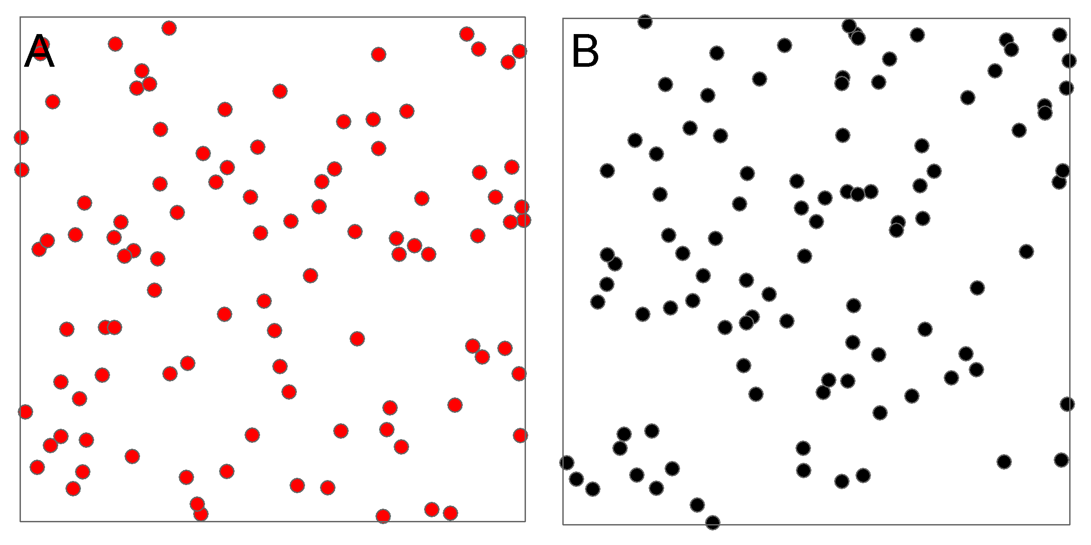

Again, we will choose to compare the densities of picnickers between both years by tessellating the space containing each year’s locations using 10 polygons and then correlating the values of the 10 polygons with each other. There should be no correlation in the density values between the two years since the picnickers are randomly distributed each year. In fact, the correlation is near 0 which means that there is no correlation using measures specifically suited to point bivariate point pattern analysis. Therefore, in reality there is no relationship between the locations of picnickers in 2021 and 2022. However, if we did not have access to the raw data and instead the same data was presented within a set of polygons then the story changes. Depending on how the polygons are created, the number of picnickers in each polygon represented as a density value in both years could easily show a strong positive correlation or, zero correlation or even strong negative correlation (Figure 9).

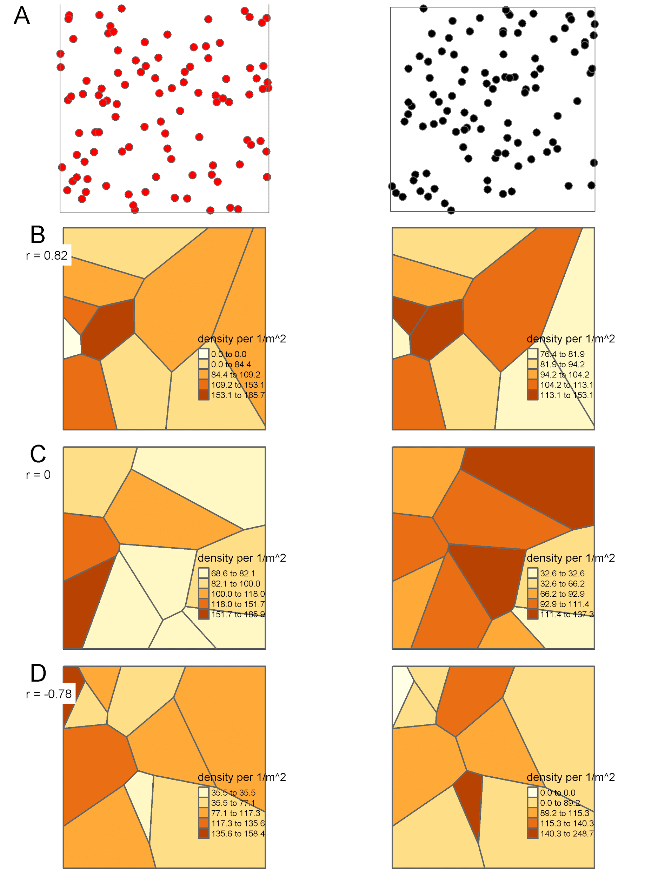

Figure 9: A) locations of picnickers in 2021 (left) and 2022 (right); B) Ten polygons that would provide a strong positive correlation; C) for the same data, a polygon set that would show no correlation; D) for the same data, a set of polygons that shows strong negative correlation. Remember the only thing that changes are the polygon configurations (zone size and zone boundaries for each zone or polygon). Note as well the density scales vary for each map in each column as explained previously. The point location never changes. The ‘r = ‘represents Pearson’s R, the correlation coefficient and while not appropriate for geographic data, it is used here to illustrate the effect of the MAUP without using more complex spatial econometric/statistical measures.

What we see in Figure 9 is the analytical aspect of the MAUP that illustrates if we change the zonation and scale of 10 polygons within the quadrant then we will get different correlations for the same underlying data. In fact, we can randomly change the 10 polygon boundaries and sizes until we land on a relationship we like. Keep in mind that we are doing this to illustrate the MAUP and in reality, you would NEVER change polygons just to get values that fit with your preconceived notions. That is called **academic fraud**.

When you work with data that are given as attributes of polygon features and those polygon features are not ‘natural units’ like say a lake, or an island, then what you might interpret or state as an analytical outcome could just be due to the configuration of polygons. This is a major problem in spatial data science and geographical analysis. You must be fully aware of this and convey that limitation whenever analyzing data from polygon geometries.

***Question 11: How do I create different zones to visualize the Modifiable Areal Unit Problem?***

Census tracts (CTs) are used by Statistics Canada to divide Canada into geographic areas consisting of around 7,500 people that follow recognizable physical features such as rivers or roads. CTs are used in Surrey, BC to separate the city into zones that are used for statistical purposes. However, the definition of the CTs can influence how the census data in question are portrayed. In this question, we will make synthetic CTs and evaluate how different zone boundaries can change the density of heritage sites per CTs. This example of the MAUP will show how the division of zones in a map can change the message of a map.

The first step will be to create a new set of synthetic CTs that have different boundaries than those defined by Statistics Canada. CTs are created through the conglomeration of Dissemination Areas (DAs), which are the smallest geographic unit used in the census. We will create a new set of synthetic CTs by using ArcGIS geoprocessing tools and Dissemination Areas. The first step is to locate the dissemination area feature class, which is located within the Census_2016_Surrey_DisseminationAreas_UTM.gdb geodatabase, inside the Surrey_Without_Data feature dataset (folder), titled “Dissemination_Areas_Surrey”. Add that to your map. Then, on the top menu bar click Analysis, then Tools, and the geoprocessing panel will show up on the left part of your screen. In the “find tool” search bar, look up “Build Balanced Zones” and then click on the tool. Set the input feature to “Dissemination_Areas_Surrey”, Zone creation method should be set to “Defined number of zones” and define the target number of zones to be 96, since that is how many CTs there are in Surrey BC. Then click “Run”. If you encounter any issues with the tool, click the upper right question mark button to access ESRI help.

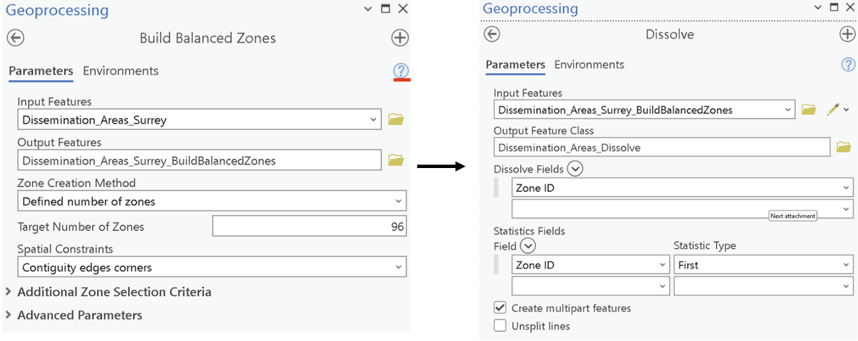

Once the balanced zones have been generated, we need to use the dissolve tool to aggregate the DAs into their synthetic CTs. Enter in the find tool search bar “Dissolve” and click on the tool. The input feature should be Dissemination_Areas_Surrey_BuildBalancedZones, and the dissolve tool should be set to “Zone ID”. Then click run to run the tool. Note that you may receive a notice that says that “The Number of Zones requested was not reached” - ignore this warning and continue to use the feature class. All outputs from geoprocessing tools default to save to the geodatabase in the home folder where your project is saved. Your output from the dissolve tool should look similar to the below map, but with different symbology for the zones.

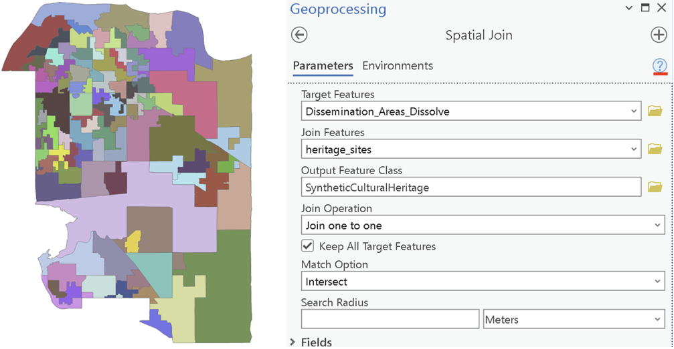

The next step is to add the heritage sites point data to the synthetic CTs using Spatial Join. A field titled ‘Join_count’ will be created and will allow us to know how many heritage sites are located within each synthetic CT. Enter in the Find tool search bar “Spatial Join” and click on the tool. Spatial join is a complex tool, so it is recommended to click the question mark button to better understand how the tool works before proceeding. Use the Spatial join with the following parameters:

* Target Features: Dissemination_Area_Dissolve
* Join Features: heritage_sites (note if you have not added heritage_sites to your map yet, click on the folder icon next to Join Features and access the heritage_sites feature class within heritage_sites.gdb).
* Join operation: Join one to one
* Keep all target features: Checked
* Match Option: Intersect

Then click **Run**.

Once you have completed the spatial join for the synthetic CTs, open SurreyCensusTracts in your map from the Census2016_Surrey_CensusTract_UTM.gdb. Do a similar spatial join where you join the heritage_sites to the SurreyCensusTracts feature class.

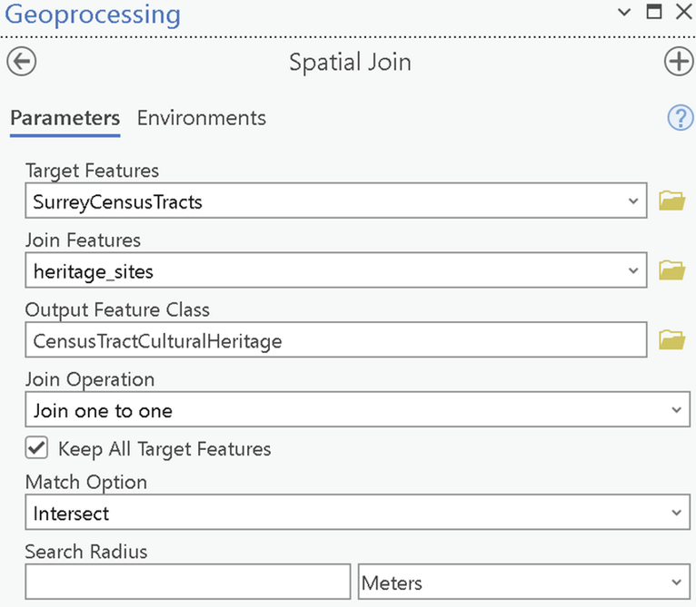

***Question 12: How do I symbolize two feature classes using the same symbology?***

This question uses a tool that allows for the user to symbolize a feature class based on the symbolization of another feature class. It is important to have the same breaks and similar symbolization when comparing results between map elements, so this is a very important tool to know how to use.

Once you have completed both spatial joins, it is time to symbolize them using the same breaks so we can make comparisons across the maps. We will be comparing the density of cultural heritage sites per zone. Firstly, let's symbolize the SyntheticCulturalHeritagefeature class. Right click on SyntheticCulturalHeritageand, select Symbology, then symbolize the feature using:

* 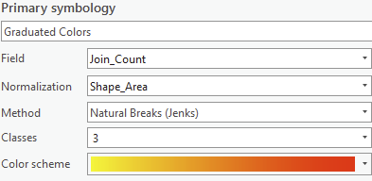Primary symbology: Graduated Colors
* Field: Join_count
* Normalization: Shape_Area
* Method: Natural Breaks (Jenks)
* Classes: 3

Then label the three classes, **low**, **medium**, and **high**.

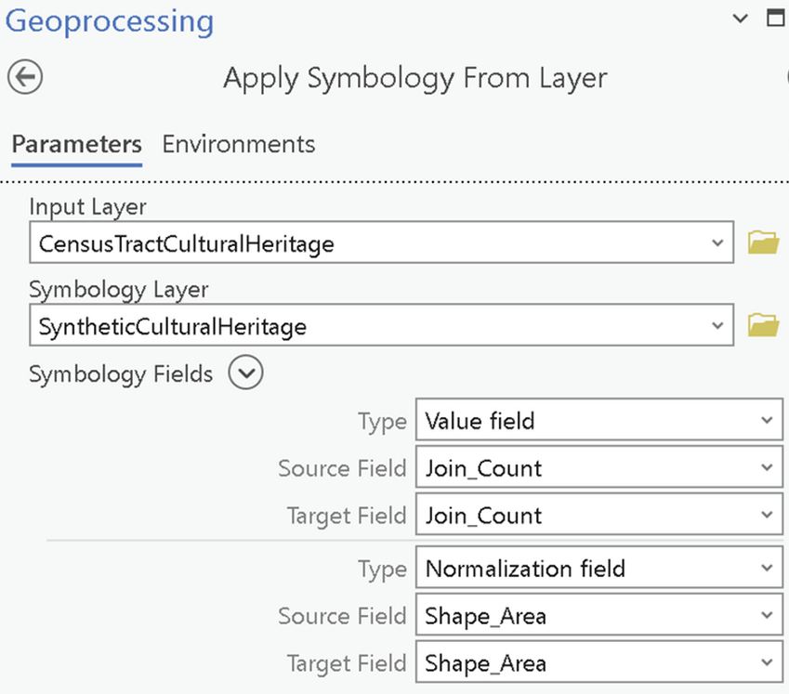Once you have finished symbolizing the SyntheticCulturalHeritage, use the geoprocessing tool “Apply Symbology From Layer” to apply similar symbology to CensusTractCulturalHeritage. Set the input layer to CensusTractCulturalHeritage, and the symbology layer to SyntheticCulturalHeritage and then run the tool.

You should now have two layers with identical symbology that can be used for comparison.

***Answer the following questions.***

1. [5 points] Create a map layout that follows the below criteria:

* There should be no basemap.
* The following historical sites should be labelled: Bulman’s Garage, Port Kells Post Office, Port Kells Fire Hall No. 7, Port Kells Elementary School, Church Manse, and Port Kells Park.
* Include the Bike routes and Ecosystem sites in this map.
* The Heritage sites should be labelled and cannot have their **site_name** touching or crossing the bike lanes.
* The map scale must be 1:10,000.
* Cartographic best practices must be used when creating this map layout.
* You must use **the Arial** font, and a different scale bar and north arrow than the below map.
* The symbology colour of the Ecosystem sites, bike routes, and heritage sites must differ from the map below.

Your map should look similar to the one below, though it does not need to be identical.

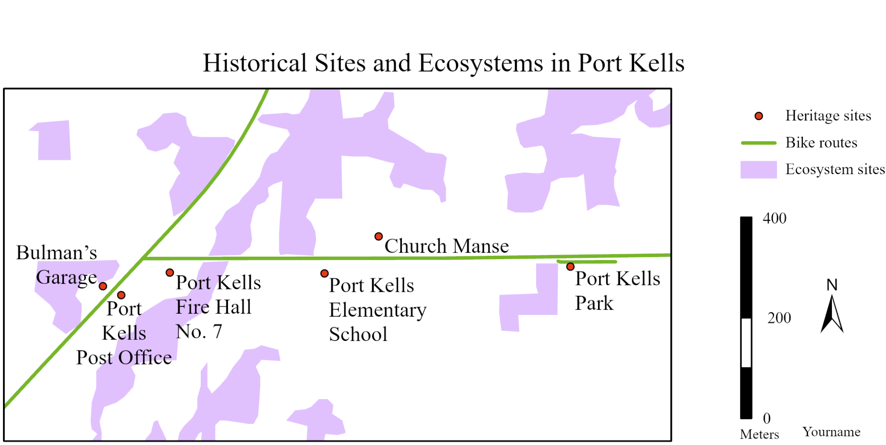

2. [3 points] In a short paragraph (max 150 words), explain how the map you submitted for Question 1 uses visual hierarchy? Why is establishing your visual hierarchy important?

3. [8 points] Similar to example questions 10 and 11, create a new synthetic census tract feature class. Then spatial join **important_trees** (located in **important_trees.gdb**) to the synthetic census tract and a census tract feature class. Using cartographic best practices, create two maps with identical symbology and map extent, with similar elements. Ensure that each map has a proper title.

4. [2 points] Explain the Modifiable Areal Unit Problem (MAUP) and how it manifests itself in the two maps you created for Question 3.

5. [1 point] If I were to create a map displaying the number of dogs found in each census tract in Surrey BC, which symbology should I use? Provide reasoning (max 100 words).

6. [1 point] If I were to create a map displaying the density of dogs found in each census tract in Surrey BC, would a Choropleth map be appropriate? Provide reasoning (max 100 words).